Purpose
If there is a many to many relationship (n to n) between fact table and dimension table then we use bridge table to resolve this relationship. Bridge table is analogy to associative entity between two entities having many to many relationships. Bridge table is also known as helper table or reference table.

Example: Let us consider the relationship between claim fact and contributing factor dimension. One claim can have many contributing factors. It holds well for vice versa case also. Hence claim fact and contributing factor dimension have many to many relationships.

Steps Involved
ETL Layer

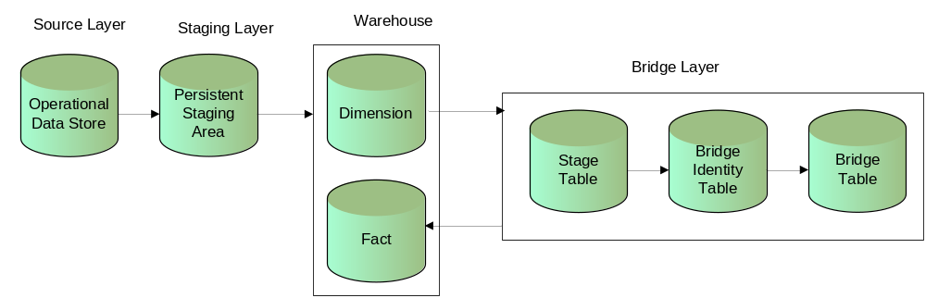

Step 1- Dimension Table
Dimension will be created to hold distinct dimensional values from the source.
Eg: The various contributing factors associated to claims are loaded into contributing factor dimension from Siebel source.
Contributing Factor Dimension
Dimension Wid | Contributing Factor LOV
1 | wet roads
2 | driving too fast for cond
3 | Raining
4 | inexperienced driver

Step 2 - Bridge Stage Table
Bridge stage table is used to group the different values of dimensional data based on their association with the fact data. It will contain one record for each group. The values and wids will be concatenated and populated into different columns.
Eg: The distinct combinations of contributing factors associated to the claims are identified. The contributing factor Integration id for this table will contain the distinct combination of values from contributing factor dimension. The bridge integration id will contain the combination of the dimension wids.
Stage Table
Contributing factor integration id | Bridge integration id
wet roads~driving too fast for cond | 1,2
wet roads~driving too fast for cond~raining | 1,2,3
inexperienced driver | 4
wet roads~driving too fast for cond~raining~inexperienced driver | 1,2,3,4

Note: The values should be sorted before grouping in order to have minimal number of records

Step 3 - Identity Table
Bridge Identity table is used to stamp a wid to each combination identified in the stage table. It is used to group the various values of dimension based on their association with the fact.
Eg: The distinct combination of contributing factors associated to the claims are identified and stamped with one identifier which will be system generated
Sequence number. The Integration id for this table will contain the distinct combination of values from contributing factor dimension.

Contributing Factor Identity Table
Identity integration id | Contr factor Bridge wid
1,2 | 1
1,2,3 | 2
1,2,3,4 | 3
4 | 4

Step 4 - Bridge Table
The various distinct combinations which are associated to fact are identified and the corresponding bridge wids are stamped with the help of identity table. In simple terms, each record in the identity table will be split into multiple records and the corresponding bridge wid will be stamped to that.

Eg: Each record from contributing factor identity table is split and the corresponding bridge wid is stamped to that.

Contr factor Bridge wid | Contr factor dim wid
1 | 1
1 | 2
2 | 1
2 | 2
2 | 3
3 | 1
3 | 2
3 | 3
3 | 4
4 | 4

Step 5 - Fact Table
The various dimension values associated to each fact record will be identified from the source, sorted, concatenated and joined with the bridge stage table in order to get identity integration id. The identity integration id from stage table is loaded into work table of the fact. While populating the fact the work table will be joined to the identity table and the corresponding bridge wid will be populated in to the fact.

Eg: The various contributing factors associated to each claim will be identified, sorted and concatenated and joined with the bridge stage table in order to get the combination of dimension wids which is the integration id for identity table. The combination of wids will be populated into the claim work table. While populating the fact the claim work table will be joined with contributing factor identity table and the corresponding bridge wid be populated into the fact.

Claim fact wid | Contr factor bridge wid
67 | 1
68 | 2
69 | 1
70 | 3

BI Layer

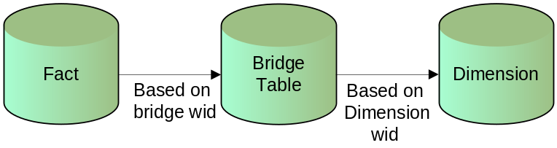
While creating reports the facts will be joined to the dimension through the bridge table.
Eg: The claim fact will be joined to the contributing factor bridge based on the contr factor bridge wid. Then the bridge table will be joined with dimension based on dimension wid

Document Change Log
Date | What | Author
09/03/2017 | Initial version | Dinakaran

